Primary Source and Transcription

# Description

This packet includes one scanned image of a primary source document and its transcription for Part 1 of “Quest for Omitted History.” A large image of the primary source on one page is followed by a second page divided in half. The left side of the page shows a smaller image of the document with the citation and credit information below it. The right side of the page is the transcription of the document.

# Table of Contents

1787 Letter from William Robinson to Joshua Ward

# Transcription Guidelines

When transcribing the handwritten document, the overall goals for us were to (1) make the text more readable and understandable for the audience and (2) to do so while keeping as much of the original text as possible. Some documents contain text that is not relevant to the lesson. On these documents, only the yellow highlighted portion on the small image is transcribed.

# Donor Recognition and Thank You

This program was made possible by a grant from the National Park Foundation through the generous support of Union Pacific Railroad and donors across the country. Special thank you to The Phillips Library, Peabody Essex Museum, The Hard History Project, and the Lynn, Salem, and Saugus Public Schools.

# Description of Primary Source

Joshua Ward (1752-1825) was a Salem shipping merchant. He began his career as partial owner of many privateers during the American Revolution. By 1782, his ships had begun trading tobacco, rum, and grains with ports in the West Indies and Europe. Ward’s vessels also sailed to Africa and Manila. This letter is from the captain of the brig Favorite, William Robinson, to the ship's owner, Joshua Ward. The letter was written in the West African country of Sierra Leone. Captain Robinson is giving a report to Ward on how much of his cargo he has been able to sell and how many enslaved people he may be able to purchase.

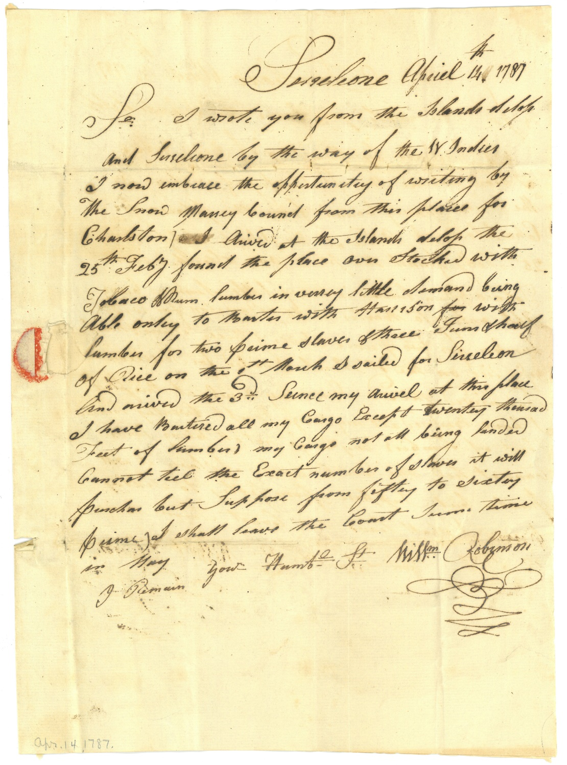

1787 Letter

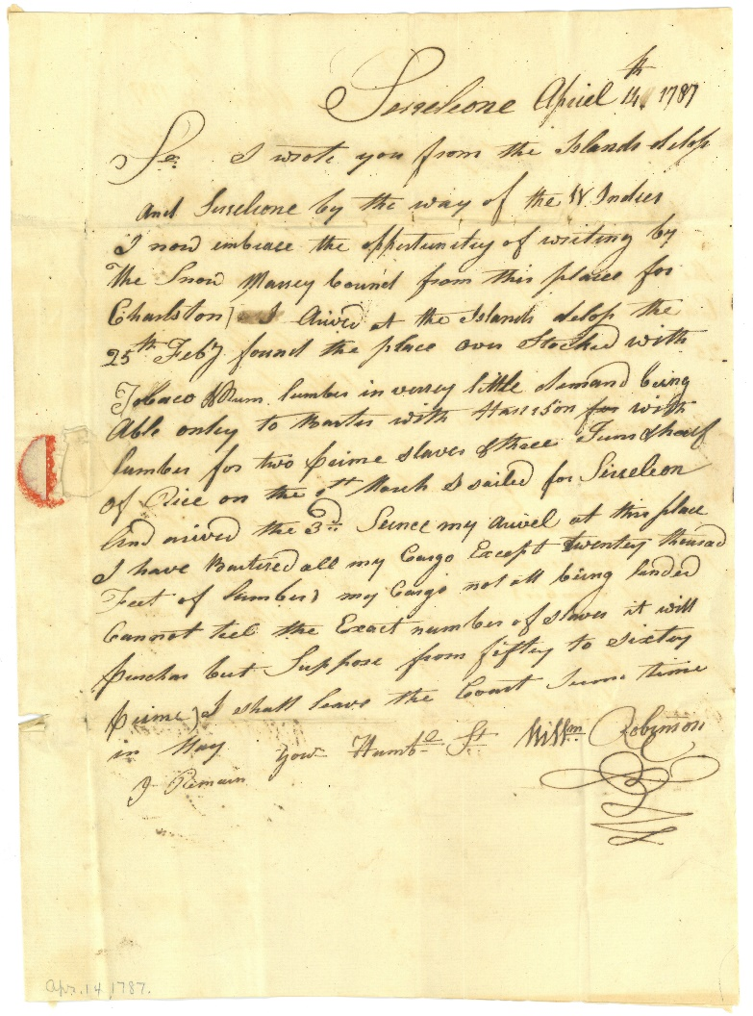

Citation and Credit:

Ward Family Papers, MSS 46, Box 4 Folder 2

Courtesy of The Phillips Library, Peabody Essex Museum, Salem, Mass.

Transcription

Sierra Leone April 14, 1787

Sir: I wrote you from the Islands and Sierra Leone by the way of the West Indies. I now embrace the opportunity of writing by the *Snow Marsey* bound from this place for  
Charleston. I arrived at the Islands the February 25th found the place overstocked with tobacco and rum. Lumber is in very little demand being able only to barter with Harrison with lumber for two prime slaves of there. I was short of rice. On the 1st of March I sailed for Sierra Leone and arrived the 3rd. Since my arrival at this place, I have bartered all my cargo except 20,000 feet of lumber. My Cargo not all being landed Cannot tell the Exact number of slaves it will purchase but suppose from fifty to sixty prime. I shall leave the coast sometime in May.

I remain your humble servant, William Robinson